**Unit 1 Foundations of Life- “What are the foundational components of life?”**

**Basic Chemistry of Life**

All living things are made of cells. Cells are surrounded by a membrane and contain internal structures that carry out the processes of life. These structures are called organelles. Organelles are made up of large molecules called macromolecules. These macromolecules are composed of smaller molecules. Molecules are made up of elements and elements consist of atoms with the same number of protons.

NOTE INTERACTION: Draw a representation of the above paragraph.

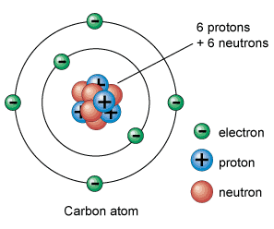

**Chemistry Review**

The drawing to the right represents a carbon atom. Please note at the center of the atom (the nucleus) are two types of particles. The ones with a positive charge are the protons and the ones without a charge are the neutrons. All carbon atoms have six protons. The number of neutrons may vary. Orbiting around the nucleus are electrons. They have a negative charge. It is the electrons that will interact with other atoms to form bonds.

For an atom to be neutral or have no charge, it must have the same number of electrons orbiting the nucleus as it does protons inside the nucleus. If it has more electrons than protons then the atom has a negative charge. If it has more protons than electrons then it has a positive charge.

Electrons orbit the nucleus in shells or orbitals. The first shell can hold 2 electrons and the second can hold 8. An atom tends toward having its outer shell full. Oxygen, for example, has 8 electrons when it is neutral. The first shell has two electrons, leaving 6 for the outer shell. Since the outer shell can hold 8, oxygen needs two more to complete that shell. This is called the Rule of Eights, or Octet Rule.

Elements are arranged on the periodic table based on the number of protons in their nucleus. Elements that have the same number of outer, or valence, electrons will have similar chemical properties. These similar elements are placed in columns on the table. 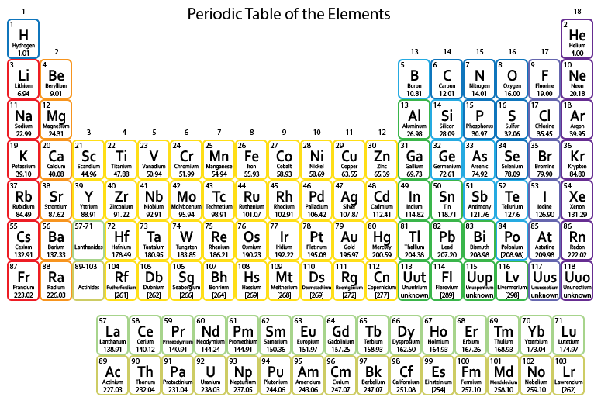

NOTE INTERACTION: The most common elements in all organisms are carbon, hydrogen, oxygen, nitrogen, phosphorus, and sulfur. Circle these elements on the table to the left and identify which of these elements have similar properties.

**Types of Bonds**

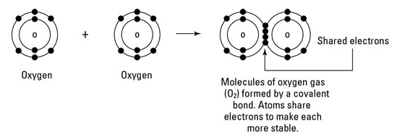

Covalent bonds are the result of electrons being shared between atoms to fill their outer shells. Covalent bonds are very strong bonds. They occur between nonmetal atoms.

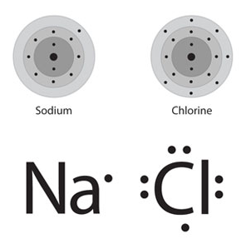

Ionic bonds are formed between a metal atom and a nonmetal atom. The metal atom became positive when it gave up an electron to the nonmetal atom. Like a magnet, these two atoms are attracted to one another. These bonds are strong when dry, but weak when wet.

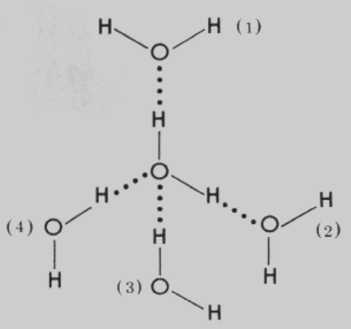

Hydrogen bonds are a bit more complicated. Some molecules are polar, which means that they have a positive side and a negative side. These charged sides are the result of an unequal sharing of electrons when covalent bonds are formed. For example, the two hydrogens in a water molecule are covalently bonded to one oxygen molecule. Because the oxygen atom has more pull on the electrons being shared (electronegativity), the oxygen side of the molecule has a negative charge. Those electrons are being pulled away from the hydrogens, so they have a positive charge. Water is polar. One side is positive; the other is negative. Hydrogen bonds are formed between negative and positive molecules. Hydrogen bonds are a type of intermolecular bond.

In water, hydrogen bonds are formed BETWEEN the molecules and covalent bonds are formed WITHIN the molecule.

NOTE INTERACTION: Look at the graphic above. Circle the individual water molecules and label the positive and negative charges. Identify the covalent bonds that connect the hydrogens to the oxygen and the hydrogen bonds formed between two water molecules.

**Water Properties and Hydrogen Bonds**

Now that you have an understanding of hydrogen bonding, let’s explore the properties of water. Water is a polar molecule which means that it has a positive end and a negative end. This is the result of polar covalent bonds between the oxygen and the hydrogen. When a molecule has oppositely charged sides, it will be attracted to other polar molecules. This results in hydrogen bonds.

Hydrogen bonds are responsible for many of the properties of water. A water molecule bonds to other water molecules (cohesion) and other polar substances (adhesion) through hydrogen bonds. Adhesion and cohesion help water move up the stems of plants against the force of gravity.

Surface tension is also the result of the cohesive property of water. Molecules at the surface are more strongly attracted to one another which makes it more difficult to move an object through the surface. This property of water allows insects to walk on the surface of the water.

Water has a very high heat of vaporization; in other words, it takes a great amount of energy input to turn water into a gas from a liquid. This property allows liquid water to absorb a lot of the Earth’s heat energy without vaporizing.

Water is less dense as a solid. Most substances contract when they get colder; water does also, but only to a point. Once water reaches 4oC the hydrogen bonds change angles and the molecules actually get further apart. Solid water is less dense than liquid water: therefore, ice floats. Ice on top of a body of water serves as insulation to the water underneath allowing aquatic organisms to survive.

Water can dissolve other polar substances creating a solution. A solution has two parts: a solvent (water in biological systems) and solute (the substance being dissolved in the water). Molecules dissolved in water can then be transported throughout the organism. If a substance is polar, then it can be dissolved in water. It is said to be hydrophilic. If a substance is non-polar, then it cannot be dissolved in water and is, therefore, hydrophobic.

**pH**

An acid will donate protons to a solution, while a base will accept protons from the solution. The pH number represents the concentration of H+ in a solution. It is calculated by -log [H3O]. If a solution has a pH number lower than 7 it is an acidic solution. If the solution has a pH higher than a 7 it is a basic solution.

Cells have an optimal pH at which they can carry out biological processes most efficiently. This pH varies from cell type to cell type.

**Organic Chemistry-”Chemistry of Carbon”**

All living things contain carbon in some form. Individual carbon atoms have an incomplete outer electron shell. With an atomic number of 6 (six electrons and six protons), the first two electrons fill the inner shell, leaving four in the second shell. Therefore, carbon atoms can form four covalent bonds with other atoms to complete the valence shell.

NOTE INTERACTION: Draw a carbon atom showing the location of the electrons.

**Macromolecules**

Macromolecules are polymers (many units) made up of monomers (one unit). These monomers are joined together by covalent bonds to make polymers. To form a covalent bond, an atom must have the need to share electrons. Removing a water from the monomers creates this need. This is known as dehydration synthesis. You must remove a water to join two monomers together. If you want to split a polymer into monomers you must add water. This is called hydrolysis.

**Carbohydrates**

Carbohydrates are made up of carbon, hydrogen, and oxygen in the ratio of one carbon: two hydrogens: one oxygen (CH2O). The monomers of carbohydrates are monosaccharides which literally means “one sugar.”

Examples of carbohydrate include sugars such as sucrose, glucose, and fructose. The main functions of carbohydrates are energy storage and structural components. Starch stores energy in plants and glycogen stores energy in animals. Cellulose and chitin are structural components of cell walls.

**Lipids**

Fats, oils, waxes, and steroids are all lipids. These macromolecules are hydrophobic (non-polar). Fats have two monomer components: glycerol and fatty acids. Like carbohydrates, lipids store energy. They also play an important role as the major structural components of membranes. Waxes protect plants. Steroids and hormones are involved in cell communication. Cholesterol helps the cell membrane remain flexible. The atoms that make up lipids are also carbon, hydrogen, and oxygen; but unlike carbohydrates, the atoms in lipids are not in the 1:2:1 ratio.

**Proteins**

Along with carbon, hydrogen, and oxygen, nitrogen and sulfur are used to make proteins. The monomers of proteins are amino acids. There are approximately 20 different amino acids that make up the proteins of most all organisms. Individual amino acids are joined together with covalent bonds known as peptide bonds. The arrangement of the amino acids determines the ultimate shape of the protein which in turn determines its function. These amino acids are assembled into proteins in the ribosomes of the cell. The functions of proteins include cell structure, catalyzing chemical reactions (enzymes), transport of molecules, and cell communication.

**Nucleic Acids**

The monomers of nucleic acids are nucleotides. These nucleotides are made up of carbon, hydrogen, oxygen, nitrogen, and phosphorus atoms. The basic components of a nucleotide are a phosphate group connected to a sugar connected to a nitrogenous base. There are two main functions of nucleic acids. One is information transfer (DNA and RNA). The other is energy transfer (ATP).

NOTE INTERACTION: On a separate piece of paper, make a macromolecule chart that summarizes the information above.

**Cell Theory, Cell Types, and Cell Size**

**Cell Theory**

There has been a tremendous amount of evidence gathered to develop the cell theory. The three parts of the cell theory were proposed in the 1800s.

1. Scientists have determined that the cell is the basic unit of life. What does this mean? The cell is the basic unit of both structure and function for living things. Cells determine what an organism IS and what an organism DOES. If you break apart a cell into its components then it is no longer able to carry out life processes.

2. Scientists have also determined that all organisms, from a unicellular bacterium to a multicellular elephant, are composed of cells. ALL living things are composed of cells.

3. Finally, scientific research has revealed that all cells come from preexisting cells. The only way to make a new cell is to divide a cell.

**Microscopes**

Microscopes were first developed in the 1600s. Over the years these instruments have become much more advanced. The first microscope was a single lens microscope; later, the compound microscope was invented. Both of these used lenses to direct light onto the organism. The first electron microscope prototype was developed in 1931. Electron microscopes use an electron beam to produce an image of a specimen on a computer screen.

Both types of microscopes continue to be important tools for the study of living things. Each type has benefits for different investigations. The light microscope allows biologists to view specimens that are living; they are inexpensive and small. The light microscope, however, has limited resolution and limited magnification. The electron microscope has a much higher resolution and magnification, but they are very expensive, very large, and can only be used to view things that are dead.

NOTE INTERACTION: Make a timeline from the dates in the above paragraphs. Using the data on the timeline, write a statement connecting the development of the cell theory and the invention of microscopes.

**Cell Types**

When you think of types of cells you might immediately think of plant cells and animal cells. Although these are indeed two types of cells, let’s broaden our understanding. When we look at all living things, again from the bacteria to the elephant, we can characterize all organisms into two categories based on the types of cells they contain. Some organisms are made up of only one cell that is very simple and does not contain any organelles surrounded by a membrane. Other organisms have very complicated cells that have organelles surrounded by membranes (including a nucleus).

All cells do share common structures. All cells must be surrounded by a cell membrane. They must contain the instructions to build proteins (DNA), and they must have structures responsible for building those proteins (ribosomes).

The DNA in the simple cells is circular, while the DNA in the complex cells is linear. The ribosomes in the simple cells are smaller than the ones in the complex cells.

NOTE INTERACTION: 1. Use the Venn diagram below to compare and contrast the two cell types.

2. Now label the simple cell side with the term Prokaryotic and the complex cell side with the term Eukaryotic.

**Cell Size**

With the exception of just a few, cells are microscopic. Why are cells so small? A cell must be large enough to hold all of the important pieces of machinery (organelles and other structures), but if a cell is too large then nutrients and wastes cannot be transported efficiently. Cells must have a large surface area to volume ratio to be efficient.

NOTE INTERACTION: Which of the following cells would most efficiently move materials? Support your answer by calculating the surface area to volume ratio of each cube.

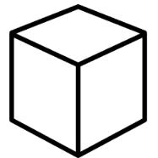  

1x1x1 cm 2x2x2 cm 3x3x3 cm

**Cell Structures**

An important concept in biology is that structure determines function. As we look at the parts of cells, let’s focus on how their structures contribute to their functions.

**Cell Structures Involved in Protein Production**

**Nucleus**

Let’s start with the nucleus. You may have learned that the nucleus is the control center of the cell, but do you know why? It is simple. The nucleus contains the code of life...DNA. The nucleus is often referred to as a vault because it contains the very valuable DNA. It is in the nucleus that the DNA code is transcribed into an RNA code. There is a structure within the nucleus called the nucleolus. This is the place where ribosomes are manufactured. The nucleus is surrounded by a nuclear membrane that has pores which serve as portals for RNA to exit into the cytoplasm.

**Ribosomes**

All cells have ribosomes, because all cells need protein. Ribosomes are composed of two types of material: rRNA and proteins. A single ribosome is made up of two subunits, one large and one small. Both of these subunits must work together to make proteins.

These little protein factories can be found in two locations in the cells. If the ribosome is floating freely in the cytoplasm, the proteins produced there will be used inside of the cell. If the ribosome is attached to the endoplasmic reticulum, the protein produced will either be exported or used in the cell’s membrane.

**Rough Endoplasmic Reticulum**

The RER is composed of a network of tubes found just outside and around the nucleus. The ribosomes dock onto the RER and deposit the protein inside as it is made. The protein is then folded inside the RER.

(In contrast to the RER, the SER does not have ribosomes attached to its surface. The main function of the SER is to manufacture lipids. It also converts toxic chemicals to safer products. A third function is to metabolize carbohydrates.)

**Golgi Apparatus**

The Golgi apparatus is a network of flattened sacs and one of its functions is to attach sugars to proteins. There are three destinations for proteins that pass through the Golgi Apparatus: 1) the lysosomes, 2) the cell membrane, 3) outside of the cell.

**Vesicles**

These are membrane bound transport structures that carry proteins between the RER and the Golgi and from the Golgi to the lysosomes and the cell membrane.

NOTE INTERACTION: Complete the flowchart below following protein synthesis from the nucleus to their final destinations.

**Cell Structures Involved in Energy Flow**

**Chloroplasts**

These organelles are double membrane-bound with the inner membrane folded in such a way that sacs are formed. The membranes of these sacs contain pigments that can absorb light which is necessary for the process of photosynthesis.

**Mitochondria**

The structure of these “powerhouses” also consists of a double membrane. The inner membrane is folded to increase the surface area. This organelle is responsible for breaking down energy rich molecules and transferring that energy to molecules that can be used for cell work. ATP is an example of an energy molecule that can be easily used for cell work.

**Evolution of the Mitochondria and Chloroplasts**

There is a vast amount of scientific evidence to support the theory that both the chloroplasts and the mitochondria were once free-living prokaryotic cells that formed symbiotic relationships with other prokaryotic cells. These symbiotic relationships, along with the enfolding of the cell membrane, gave rise to eukaryotic cells. Mitochondria and chloroplasts have many similarities to prokaryotic cells. They have their own DNA which is circular and their ribosomes are the same size as the ribosomes in prokaryotes. Even their double membranes point toward endosymbiosis, further evidence that they were each engulfed by a primitive host.

NOTE INTERACTION: Complete the chart below.

|  |  |  |  |
| --- | --- | --- | --- |
|  | Prokaryotic Cell (Bacteria) | Chloroplast | Mitochondria |
| DNA Shape |  |  |  |
| Ribosome Size |  |  |  |

**Other Cell Structures**

**Lysosomes**

These are membrane-bound sacs full of digestive enzymes. They are involved in the digestion and recycling of molecules. Enzymes are proteins and you may recall that the lysosome is one of the destinations for proteins that are made in the RER.

**Vacuoles**

These organelles are membrane-bound sacs used for storage of various substances. Plant cells have a large central vacuole used to store water.

**Cytoskeleton**

This structure is made of microtubules and microfilaments. The cytoskeleton helps to support and protect the cell, helps to organize the organelles, and helps organelles move.

**Cell Wall**

This structure is found in all plants, all fungi, some Protists, and some bacteria and serves as protection for these cells. The cell walls are composed of various sugars.

**Extracellular Matrix (ECM)**

This structure is actually found outside of the cell and is composed mainly of glycoproteins and glycolipids. The ECM serves as a protective outer “skeleton” and also functions in communication with other cells. Cartilage and bone are examples of ECM.

**Cell Membrane Structure**

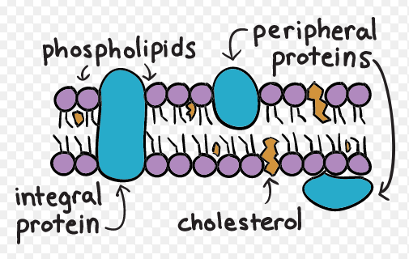

The cell membrane separates the inside of the cell from the outside of the cell. Its structure is said to be selectively permeable, allowing certain materials to pass in and out, while prohibiting the movement of other materials. Because of this, the cell membrane plays a role in maintaining a stable, internal environment.

There are three major components of the cell membrane:

**Phospholipids**

These molecules are made up of a phosphate head and two lipid tails. The phosphate head is charged and is, therefore, hydrophilic. The lipids tails are uncharged making them hydrophobic. When phospholipids are in a watery environment they spontaneously form a bilayer with the phosphate heads facing outward towards the water and the lipid tails facing inward away from the water.

**Proteins**

There are two basic types of proteins involved in membrane structure. The integral proteins completely span the bilayer while peripheral proteins are located either on the inside or the outside of the bilayer. Proteins perform several functions in the cell membrane. Some proteins help move food, water, and other materials across the membrane. Other proteins are enzymes that catalyze chemical reactions. There are proteins in the cell membrane that are responsible for cell to cell communication and cell recognition. Some are signal receptors, while others serve as intercellular junctions and attachment points for the cytoskeleton and the extracellular matrix.

**Cholesterol**

This lipid molecule helps keep the membrane fluid and flexible.

**Movement across Membranes**

Small, uncharged molecules (such as O2 and CO2)have the ability to diffuse directly across the phospholipid bilayer. Any molecule that is charged (such as ions or water) requires a transport protein to move through the bilayer.

There are two major types of transport. Passive transport does not require energy from ATP; active transport does.

A solution has two components, solvent and solute. The universal solvent in biology is water. The solute is the “stuff” that is dissolved in the water. Salt and sugar are examples of solutes. Tonicity is the amount of solute in a solution. If we are comparing two solutions (say, the solution inside a cell to the solution outside of the cell) a solution is said to be hypertonic if it has more solute. The solution with less solute is said to be hypotonic.

NOTE INTERACTION: Draw a cell that is hypertonic to the surrounding solution by representing the solute on the inside and the outside of the cell.

**Passive Transport**

When molecules move from high concentration to low concentration, energy from ATP is not required. This type of transport is called passive transport. There are three different types of passive transport.

*Diffusion*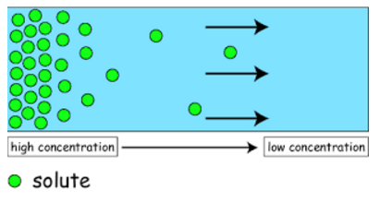

Simple diffusion is the process in which molecules move from an area of high concentration to an area of low concentration until equilibrium is achieved.

*Osmosis*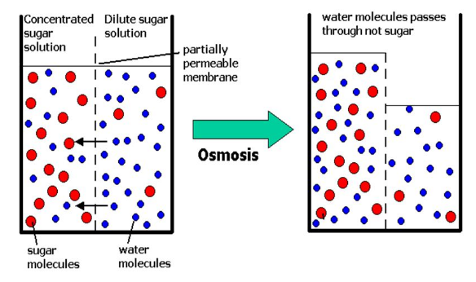

Osmosis is the diffusion of water from a hypotonic solution (lower concentration of solute) to a hypertonic solution (higher concentration of solute). Water always moves toward the hypertonic area. If we talk in terms of water potential, water moves from high water potential to low water potential.

*Facilitated Diffusion*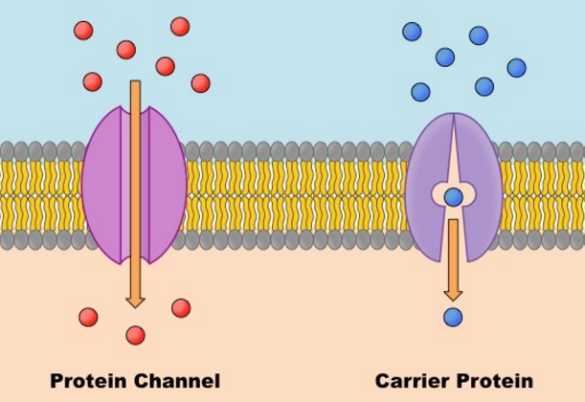

This is where the membrane proteins are utilized. Materials are still moving from high concentration to low concentration, but because they are charged or large and cannot pass directly through the membrane, they require a transport protein to travel across the membrane. Water and ions pass through the membrane in the manner.

**Active Transport**

Sometimes it is necessary for molecules to move into and out of the cell against the concentration gradient. This requires energy in the form of ATP or from the movement of electrons. Active transport is important in neurons and in the processes of photosynthesis and cellular respiration.

**Bulk Transport**

When there are very large molecules that need to be moved out of the cell, a vesicle containing these molecules merges with the cell membrane and expels its contents to the outside of the cell. This is called exocytosis.

Large molecules enter a cell by a process called endocytosis. This also involves a vesicle. The membrane surrounds the substance and it becomes completely enclosed by the membrane. At this point a vesicle pinches off and moves the substance into the cytoplasm.

NOTE INTERACTION: For the scenarios below, place an X in the transport column that correctly identifies the movement of the molecules.

|  |  |  |  |  |
| --- | --- | --- | --- | --- |
| Scenario | Simple Diffusion | Osmosis | Facilitated Diffusion | Active Transport |
| A unicellular organism eating its prey |  |  |  |  |
| CO2 leaving a cell |  |  |  |  |
| Water entering a chloroplast |  |  |  |  |
| A hydrogen ion (H+) crossing a cell membrane |  |  |  |  |

**Cell Communication**

In multicellular organisms, it is essential that cells communicate with one another. Cells communicate by using chemical messengers.

**Types of Cell Signaling**

Direct signaling involves physical contact between cells. Heart cells communicating with one another to coordinate the contractions which result in a heartbeat is an example of direct signaling.

If the cells are in close proximity to one another, but not touching, this is local signaling. Nerve cells communicate by local signaling.

If the signal must travel to the target cell using the circulatory system, this is long distance signaling. The best example is when Hormones are produced in glands and travel to cells all over the body through the bloodstream.

**Signal Transduction Pathway**

Cells communicate by using chemical signals. These signals require a specific receptor either on the membrane of the cell (polar signals) or within the cytoplasm (nonpolar signals). The signal causes the protein to change shape which triggers a series of chemical reactions (transduction) which results in a cellular response.

RECEPTION TRANSDUCTIONRESPONSE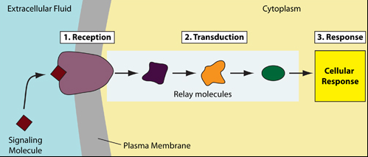

**Cell Cycle Part 1**

Like many living things, cells have a life cycle. They carry out the function that their structure dictates. They grow and reproduce.

**The Cell Cycle Phases**

*Interphase*

This phase includes three distinct sections:

G1 is the phase in which the cell performs regular cell functions. It grows and it carries out metabolic processes. In the S phase, DNA is replicated. There is now double the amount of genetic material, enough for two cells. In the G2 phase, the cell and its organelles continue to grow. It is in this phase that the contents of the cytoplasm (organelles) finish replicating to insure that there is enough material for two cells.

*Mitosis*

The process of mitosis is the division of the nucleus and occurs in four phases:

In **prophase**, the nuclear membrane breaks down and the chromatin (DNA) condenses into chromosomes (DNA). In animal cells, centrioles move to opposite sides of the cells and help direct the chromosomes during division using spindle fibers.

In **metaphase**, the chromosomes align along the middle of the cell.

In **anaphase**, the chromosomes separate and travel to opposite sides of the cell.

In **telophase**, the nuclear membrane reforms around each set of chromosomes. The chromosomes de-condense into chromatin. You now have two distinct nuclei.

NOTE INTERACTION: Focusing on the chromosomes, sketch each phase of mitosis.

|  |  |  |  |
| --- | --- | --- | --- |
| Prophase | Metaphase | Anaphase | Telophase |
|  |  |  |  |

*Cytokinesis*

Once the nuclear material has separated, the cytoplasm and its contents must split. The process of cytokinesis differs in plant and animal cells. In animal cells, the cell membrane, with the help of microfilaments, starts to enfold on opposite sides of the cell, forming a cleavage furrow. In plant cells, a cell plate forms between the two cells. The process of cytokinesis completes the cell division process and now you have two genetically identical cells.

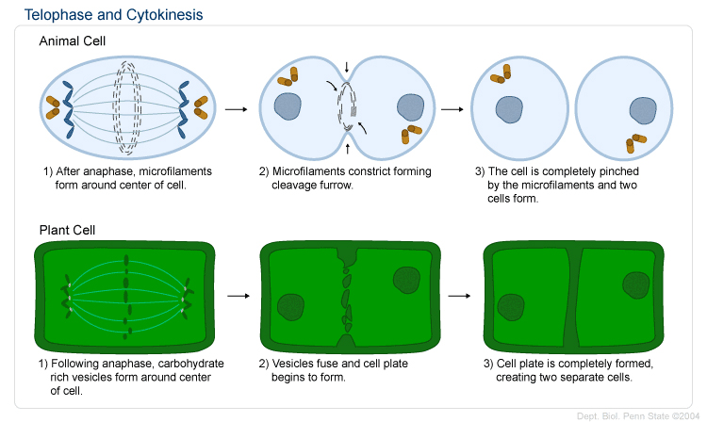

**Cancer and the Cell Cycle**

When mitosis is not controlled, the cells keep dividing and form masses of cells. These masses are called tumors. If the masses are contained, then they are benign tumors. If the masses invade the surrounding tissues, they are malignant tumors.